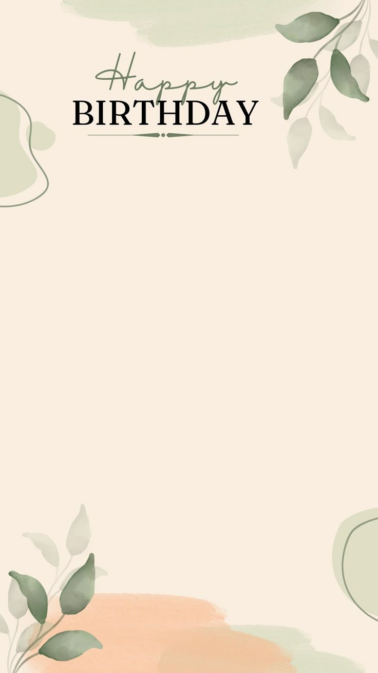

Wishing you a beautiful year ahead filled with grace, love,an meaningful moments.
Whishing you good health and a year full of abundance and blessings.

